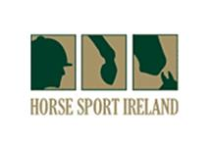
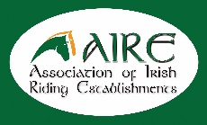

AIRE Training Day

“Jumping Exercises for all levels”
at
Tipperary Equestrian Centre
on
Monday 10th October 2016 at 10am
with
Comdt. John Ledingham H.S.I. Level 3
Show Jumping Coach

Chef d’Equipe to the Children on Horses, Junior and Young Rider Show Jumping teams, who took home Individual and Team medals at the 2015 & 2016 European Championships.

John also manages the Irish Sport Horse Studbook Team at the World Breeding Jumping Championships for Young Horses at Lanaken, Belgium.
In 2015 and once again in 2016 Ireland have taken home a haul of medals.

Cost: €45. Tickets can be booked at €40 if pre-paid by Monday 3rd October
Cheques should be posted to A.I.R.E, Beech House, Millennium Park, Naas, Co Kildare.

The event will be counted as a Continuous Professional Development (CPD) training day for Instructors and Coaches by the British Horse Society, Horse Sport Ireland, Irish Pony Club & AIRE.

Soup and sandwiches will be available to purchase on the day.
Please wear extra layers and bring a knee blanket to help keep warm!
Approximate Finish 3.30pm.
All welcome.

