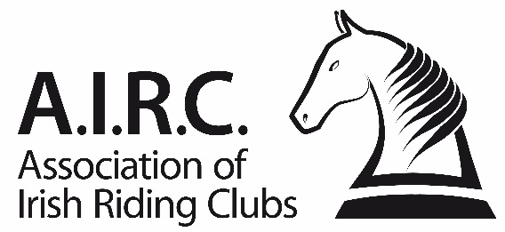
Ref: F80/15
Amended: 25/01/2023
Show Officials Application Form

Section 1 | Applicants Details
Name:
Club: |  | AIRC No.
Contact Number:
Email Address:

Section 2 | Role and Level
Please select the role and level for which the applicant is applying for below using the drop down menus:
Role: |  | Level (Club / Regional) | If Dressage, up to what level permitted:

Section 3 | Qualifications and Experience
Outline the applicants relevant experience and any external qualifications confirming their suitable for the role(s) outlined above. Provide as much information as possible in order to help your application.

Section 4 | Reference & Mentoring
Reference | Please attach a written reference from an individual who is currently on a Dressage Ireland or ShowJumping Ireland officials list relevant to the role you are applying and they must be of a similar or higher standard.
Name:
Contact Number: |  | Email:
Mentor | The applicant is required to have a mentor, with whom they can seek advice. They must on a Dressage Ireland or ShowJumping Ireland officials list relevant to the role you are applying & they must be of a similar or higher standard.
Name:
Contact Number: |  | Email:

Section 5 | Shows Experience
Please outline any shows where you have assisted or performed duties relevant to the role you are applying, in the previous 12 months.
Date of Show | Show Name | Brief Description of role

Section 6 | Applicants Declaration

I hereby confirm that the above information is true to the best of my knowledge and would like to be considered for the above role. I understand that if my application is successful, my details will be published on www.airc.ie.

Tick this box if you do not want your contact information (contact number & email) published on www.airc.ie.

Applicant: Date:
(Signature, not typed)

Section 7 | Club Declaration

I hereby confirm that the above information is true to the best of my knowledge this application was considered at a committee meeting held on and our club would like to put the applicant forward for consideration.

Club Chairperson: Date:
(Signature, not typed)

Club Secretary: Date:
(Signature, not typed)

Notes

- Please type the information on this form, using the available fields, before printing it.
- Only members an affiliated club of the Association of Irish Riding Clubs may be considered for inclusion on the AIRC’s list of approved show officials.
- Only those approved for regional activities may officiate at any inter-club or regional event (i.e. an event involving members from more than one club) in accordance with rule 5.5.

Please return this completed form, along with a reference, to:

AIRC, 1st Floor, Beech House, Millennium Park, Osberstown, Naas, Co. Kildare, W91 TK7N.

Or email a flat scanned copy to info@airc.ie with ‘Show Officials Application’ in the subject line.

