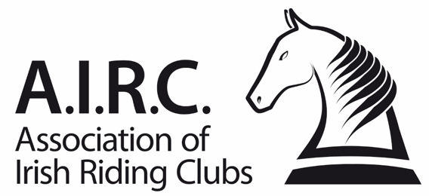
Ref: F22b/22
Amended: 22/03/2023
Members Downgrade Application Form

Applications for downgrade must be authorised by the Regional Grading Advisory Committee before applying to National Office. AIRC reserves the right to deny any application for downgrade.

Section 1 – Members Details

Membership Number | Members Full Name
Club

Members Grades
Please select the members current grades and their proposed new grades from the drop-down menus below:

 | Dressage | Show Jumping | Cross-Country
Current Grade
New Grade

Reason for Application
Please outline below, in as much detail as possible, the reason as to why the club committee is applying for a downgrade for this member:

Section 2 – Horses
This section is to be completed by the Member. Please list any horses below which the member has competed on in AIRC and/or any unaffiliated competitions, such as Dressage Ireland, Eventing Ireland, ShowJumping Ireland or other unaffiliated competitions up to and including past two calendar years.

Registered Name (Passport) | ULEN

Section 3 – Equestrian Qualifications
This section is to be completed by the Member. Has this member attained any equestrian qualifications, in particular, in relation to riding?

Qualification | Year Attained

Section 4 – Performance Record
This section is to be completed by the Member. Please list below the members competition results in any unaffiliated competitions, such as Dressage Ireland, Eventing Ireland, ShowJumping Ireland or other unaffiliated competitions up to and including past two calendar years.

Failure to declare all competitions will result in this application being rejected. Please attached additional results on a separate page, if needed.

Date | Discipline | Show | Competition | Result / Score | Place

Please outline the AIRC dressage competitions that this member has competed in the past 12 months. Please note that you must have competed in at least two open competitions, as per rule 8.1.2., at the level at wish they wish to downgrade to.

Date | Show | Competition | Judge | Result / Score | Place | Starters in Class

Please include a copy of the test sheet and a copy of the master results of the competition.

Section 5 – Club Declaration
This section is to be completed by the Club Officers outlined below.

I hereby declare that our club committee has reviewed and authorised this application for consideration for downgrade.

This application was reviewed by our Club Committee on this date -

Club Grading Officer: Date:
(Signature required, not typed)

Print Name:

Club Secretary: Date:
(Signature required, not typed)

Print Name:
Please note:
- The form must be signed by both club officers above.

Application Process
- Step 1 Complete all sections of this form.
- Step 2 Forward the application to your regional secretary and a retain a copy as this will be required when applying to National Office.
- Step 3 Once the Regional Grading Advisory Committee has approved the application, they will then notify National Office that the downgrade has authorised. The Club Secretary of the applicant will also receive notification of this once the application has been approved.
- Step 4 The club must then apply to National Office via www.airc.ie/shop for the grades to be amended. You will be required to upload a copy of this form and pay a fee during the online application process.

