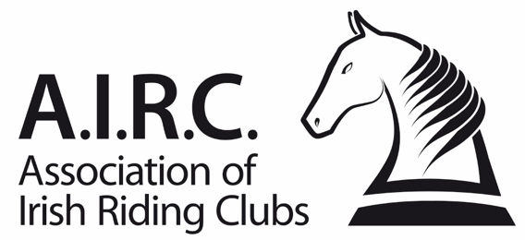
Ref: F22a/21
Amended:
Members Upgrade Authorisation Form

The change of grade (upgrade only) for the member below has been approved by the full Club Committee and has been recorded in the minutes of the meeting of the committee.

Members Details

Membership Number | Members Full Name
Club

Members Grades
Please select the members new grades from the drop-down menus below:

New Dressage | New Show Jumping | Cross-Country

Reasoning of Committee’s Authorisation
Please outline below the reasoning as to why the committee has approved this application:

Date of Committee Meeting
This application was reviewed and authorised by the Club Committee on this date -

Declaration
I hereby declare that our club committee has reviewed and authorised this application.

Club Grading Officer: Date:
(Signature, not typed)

Print Name:

Club Secretary: Date:
(Signature, not typed)

Print Name:

Please Note:
To process this application, you must apply via www.airc.ie/shop and upload a copy of this form to accompany the fee. The form must be signed by both officers above.

